



Users Guide
Plant Growth Monitoring System
`
  - Wilmer Suarez
  - 109592501



Table of Contents

1. Introduction 2
1.1 Purpose of this Document 2

2. System Overview 3

3. Using the System 4
3.1 User Interface/Control Panel 4
3.2 Data Flow/System Configuration 10

4. Errors 13

5. Specifications 14
5.1 Temperature/Timing 14
5.2 Electrical 15

- Introduction
The Plant Growth Chamber has been designed to provide easy and complete plant monitoring.
The product is assured to be reliable and safe. Designed for natural or experimental environments. You can be confident in using the system to its full intended use and potential.

1.1 Purpose of this Document
This manual defines the use and instructions needed to use the Plant Growth Chamber correctly and safely.
- You should try and keep the manual nearby to certify correct use of the instrument.
- Read the manual in in detail for correct operation and to avoid mistakes.
- This manual is intended only for the instruction on how to operate the instrument. For full technical detail, read the separate Theory of Design document.
- Before use, unpack the instrument, carefully, and check for damage.

- System Overview
The system provides and easy to use interface that will allow the changes to the display and alarms to be set. The specifics of the interface will be described in the next section: 3. Using the System.
The capabilities of the system include:
- Time keeping (with Alarm)
- Measurement of relative Temperature
(In degrees Celsius or Fahrenheit).
- Measurement of Relative Humidity
- CO2 Sensor

Note:
- The system arrives with a default time of 00:00:00.
- The alarm is also set to the same pre-defined values (turned off).
- Upon reset, the default values will be re-configured (You would need to set your preferred time again).

- Using the System
  - User Interface/Control Panel
Figure 1 - Front Panel Diagram
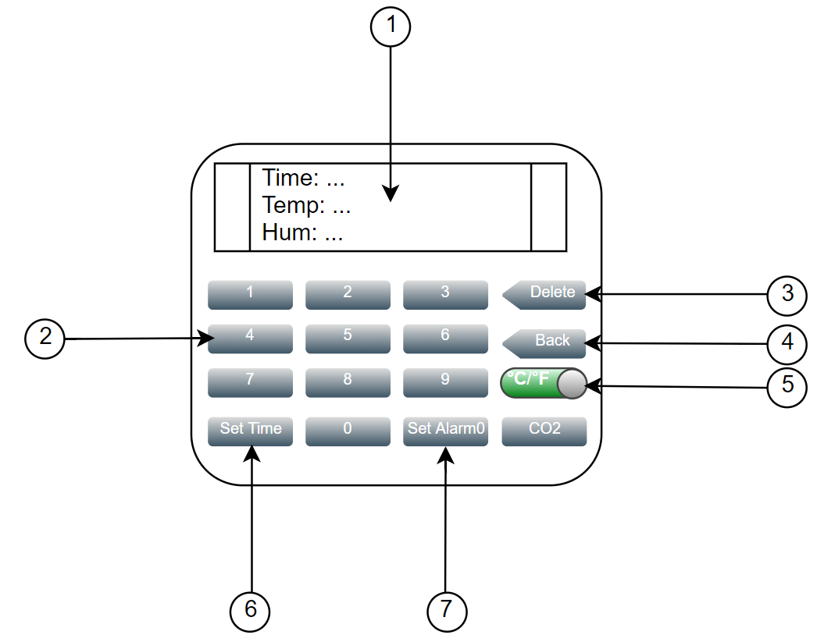

- Display

The display shows – initially – the measurements of Time (24-hour format), Temperature (Celsius), and the Relative Humidity percentage.

Note:
- The measurements are automatically updated every second.

Example:
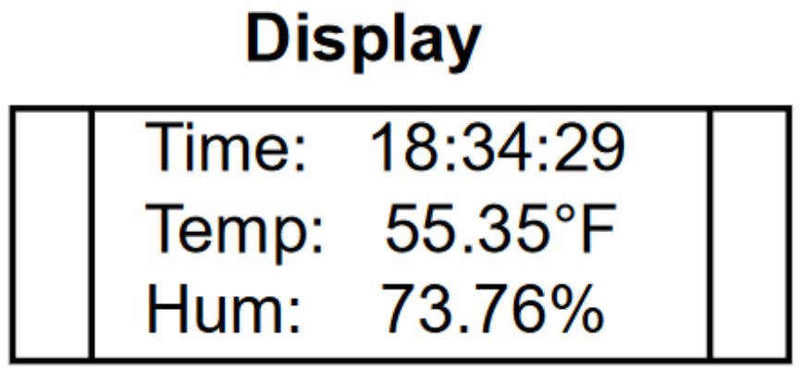

- Number Pad

Number pad (0 9) is used as input to change the current Time/Day and setup the Alarm.

- Delete Button

The delete button is used to fix accidental key presses by moving the current position of the cursor backwards by one.

Example:
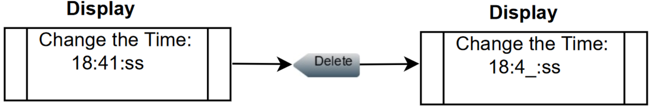

- Back Button

This button returns the user to the main screen.
Example:
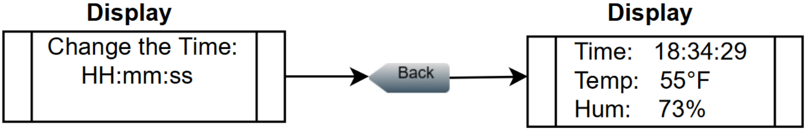

- Celsius/Fahrenheit Button

This button lets the user choose between displaying the Temperature in Celsius or Fahrenheit.

Example:
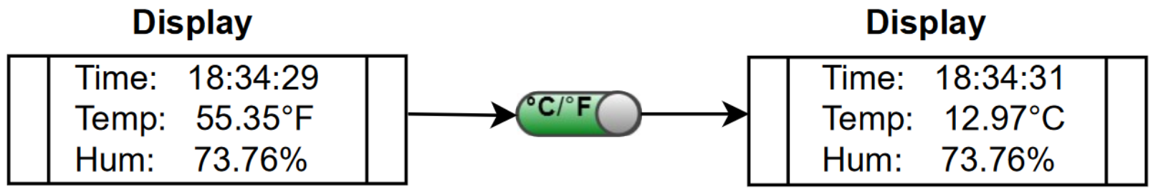

- Set Time Button

This button is used to display the “Change Time” state.
Here a user can input the time to display, the day of the week, the day of the month, the month, and the year.

Example in section 3.2.

- Set Alarm Button
Like the Set Time Button, this button allows the user to decide when the alarm should occur.
The alarm can occur:
- Once per week.
- Once a day.
- Once an hour.
- Once a minute.
- Once a second.

Example in section 3.2.
- CO2 Button

This button will display the current CO2 readings.

Example:
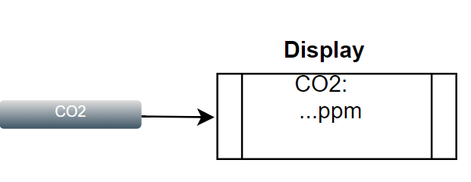

Pressing the Back Button will return you to the initial display of Time, Temperature, and Humidity:

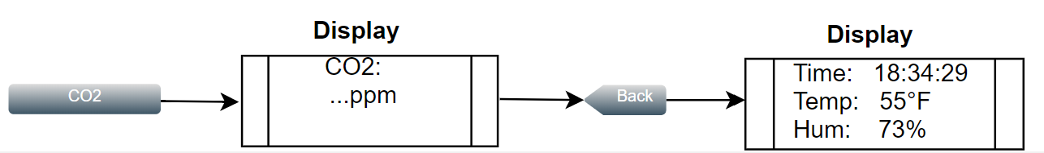

Figure 2 - Back Panel Diagram
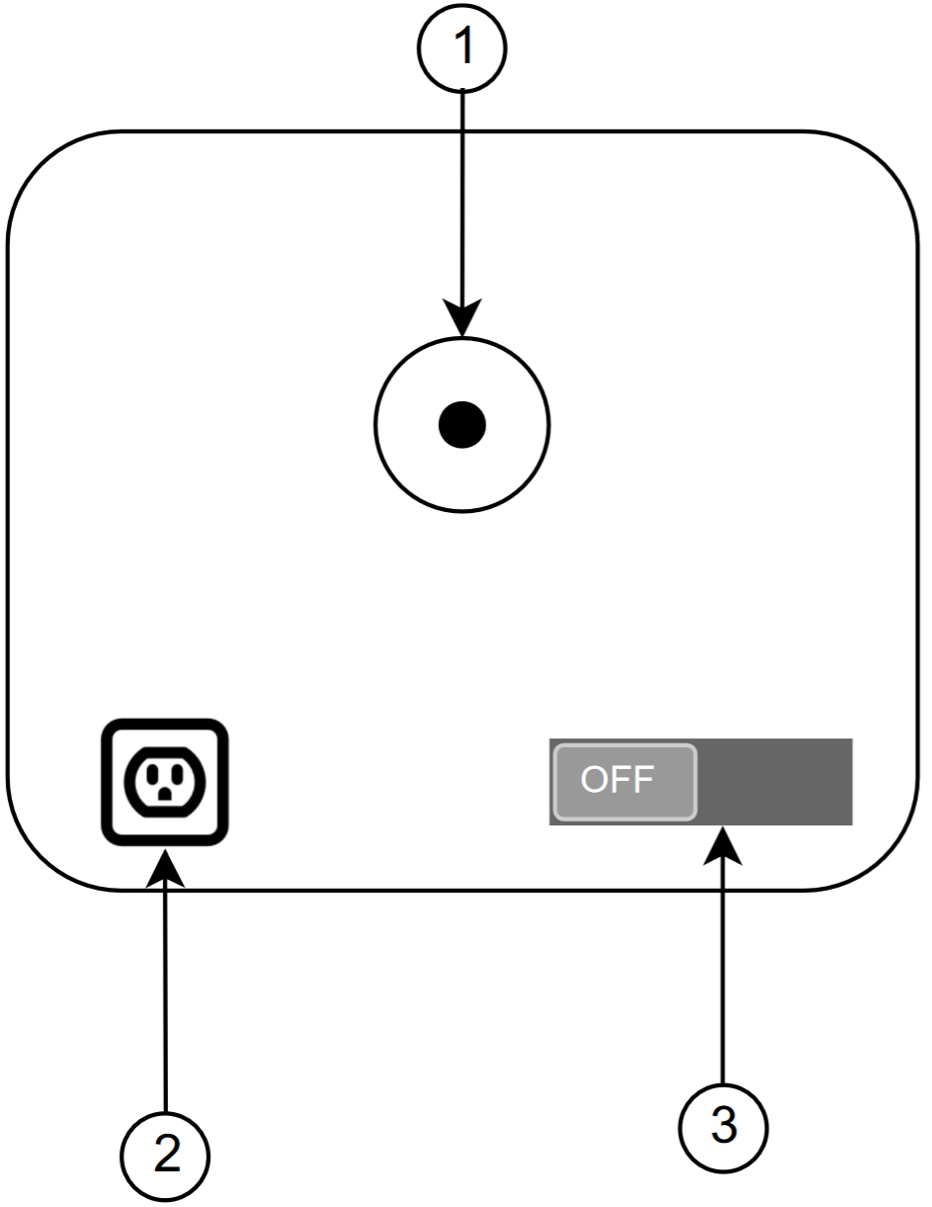

- Coin Battery Holder

A +3-volt Coin Battery holder used for backup power for the internal Real Time Clock. This ensures consistent time kept even if the device gets powered off (deliberately or not).

- Power Socket

Power socket connection for +5-Volt power supply

- On/Off Switch

Turns system On or Off.

  - Data Flow/System Configuration
Figures 3 and 4 below contain two diagrams displaying how to setup the system to input the Time and Date desired and setup the Alarm.

Figure 3 – Set Time Configuration
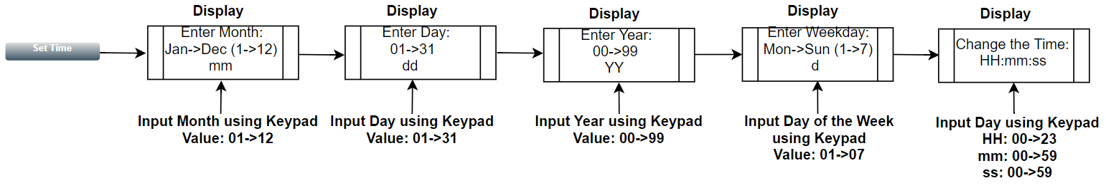

Figure 4 – Set Alarm Configuration
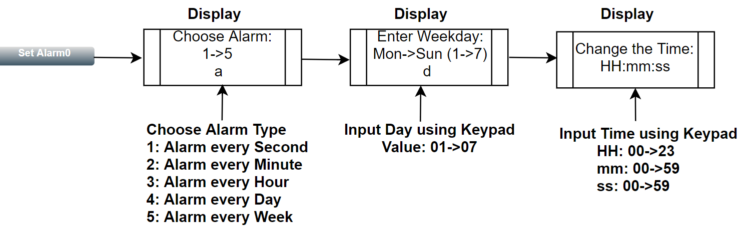
- Errors
An error message can occur if a certain button that has no effect in the current state is pressed.
Example:
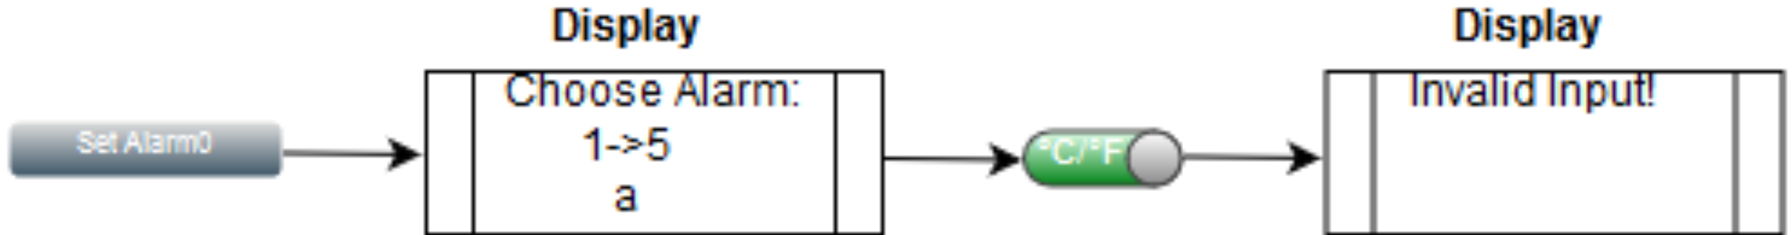

This error message can occur in any of the four states:
- While choosing and configuring an alarm.
- While configuring the time and date.
- During the initial state (displaying timing, temp, hum.)
- And During the display of the CO2 measurement.

- Specifications
5.1 Temperature/Timing
Honeywell HumidIcon:
- Provides a temperature range of 5°C 50°C (41°F 122°F)
- Max temperature supported (Operating temperature): -40°C 125°C (-40°F 257°F)
- Reliable – MMTF (Mean time for failure) – for up to 9,312,507 hr
DS1306 Serial Alarm RTC:
- Storage temperature range: -55°C + 125°C
- Operating temperature range:
  - Commercial: 0°C +70°C
  - Industrial: -40°C +85°C
SEN0219 COS Sensor:
- Operating Temperature: 0°C + 50°C
- Reliable for > 5 years

5.2 Electrical
DS1306 Serial Alarm RTC:
- Operating Voltage: 2.3 ~ 5.5V
- Operating Current: 0.6μA
- Peak Current at 5V: 150Ma

Note: The device’s Real Time Clock needs to constantly have a source of power to ensure that the correct time will always be kept/displayed.
Thus, before disconnecting the device from power, make sure that the backup battery is working.

Honeywell HumidIcon:
- Operating Voltage: 2 ~ 5.5V
- Battery Voltage: 2 ~ 5.5V DC

SEN0219 COS Sensor:
- Operating Voltage: 4.5 ~ 5.5V
- Operating Current: < 60mA at 5V
- Peak Current at 5V: 150mA
- Output Voltage: 0.4 ~ 2V

